**Creation of IBM CLOUD SERVICES**

|  |  |
| --- | --- |
| Team ID | PNT2022TMID043525 |
| Project Name | Smart waste management system for metropolitan cities |

**JIRA SOFTWARE AND SCREEN SHOTS**

**ROADMAP**

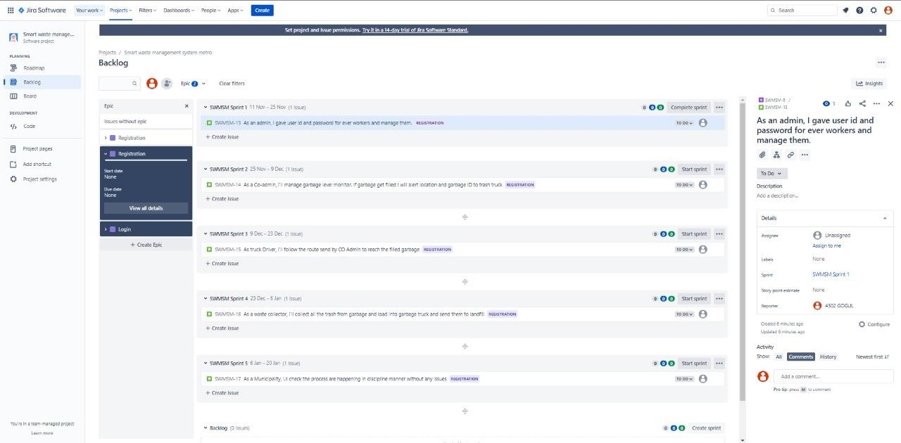

# PROJECT PLAN

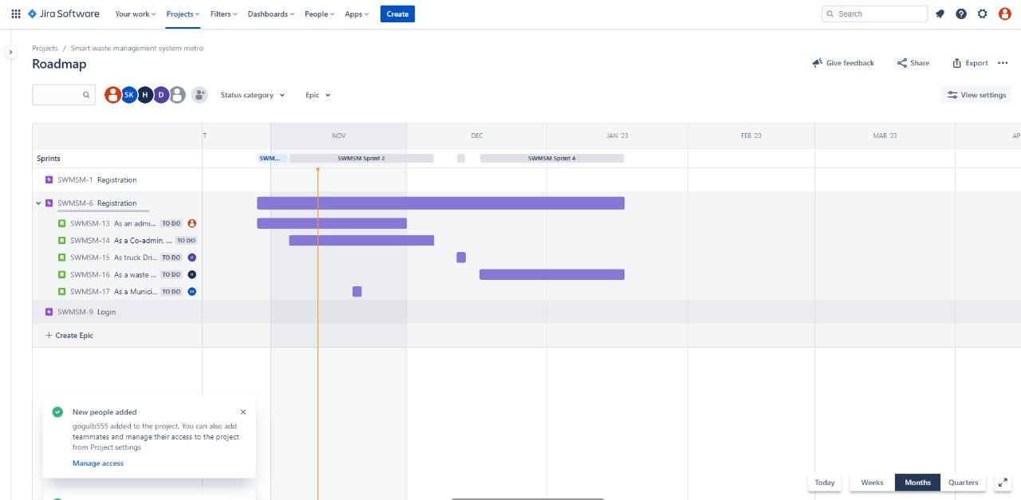

# SPRITS

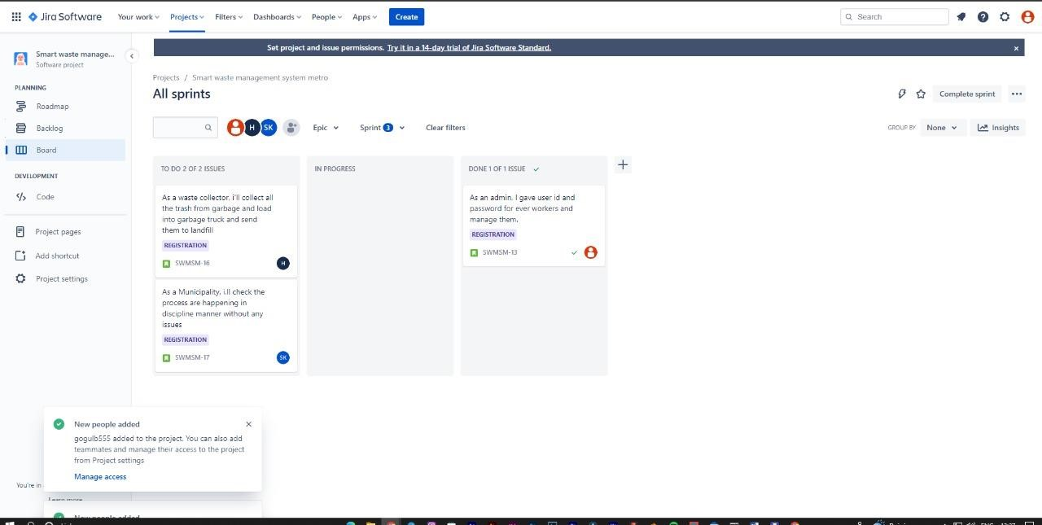

# BURNDOWN CHART

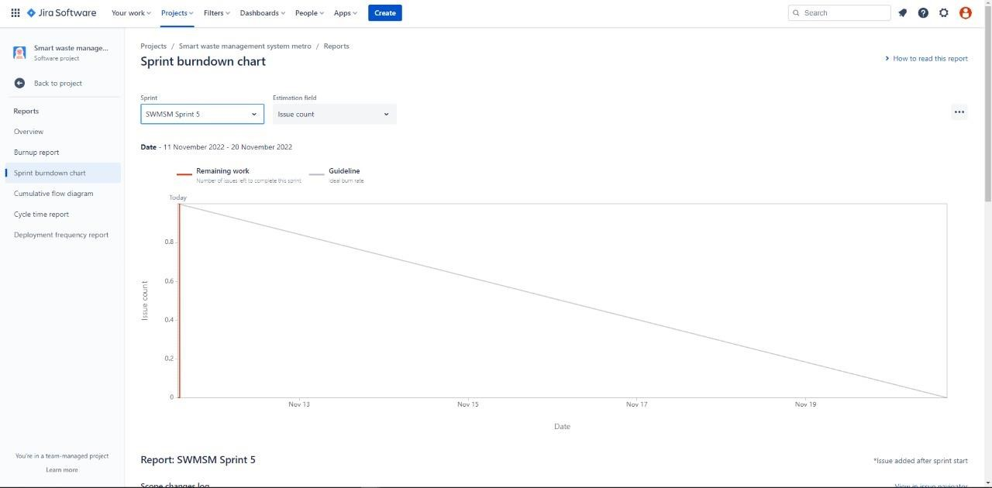

# TIMELINE

